# Javascript 1: Exercises

Set up a html page and link a javascript file to it with the script tag. Now implement the following in the

javascript file:

## Variables / Data types / Objects / Arrays / Functions

1. Declare and assign values to variables for each of the data types Boolean, Number, String, Array and Object and display all the values in the console.



1. 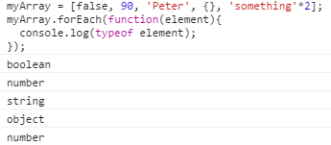Create an array of a string, number, object and boolean value and display the type of the values in the console by looping the array.
2. Create an object with two properties: studentId and studentName and add a toString method, that returns the two properties in a single string. Create an array with 3 students and loop the array displaying the result of the toString method in the console.
3. Create an object with a list (an array) of students (each student has a name an age and a gender as Boolean: isFemale) create a method in the object that can return the youngest student and another method that can return all female students. Test the program by writing all female students to the console.
4. Create a function that can take a sorted array of student objects and a single student object as parameters. The function should return an array where the student is removed in a way that the new array is of a length equal to the old array minus one.
5. Use the foreach() method of the array to loop through an array and display the names of any student above 30 years of age. Test the result by writing to the console.
6. Write a function max(), that takes any number of arguments and uses the arguments object returns the largest of them.
7. Write a function that returns the current day as a string, i.e Monday, Tuesday …
8. Create a prototype for animal objects with at least 4 properties and one method. It must have a Boolean isMammal and a name property. Create a number of animals and loop over the collection while writing their properties to the console.
9. Use the array filter() method to filter animals out that are not mammals
10. User the array map() method to get a resulting array with just the names of each animal as strings.
11. Extra exercise if you need a challenge:

write your own map function that can take an array and a function (this would be a callback function) as 2 arguments and can return an array based on the elements that returned true when fed to the callback function.

